## The Holocaust, Climate Science and Proof

February 4, 2015 by [scienceofdoom](http://scienceofdoom.com/author/scienceofdoom/" \o "Posts by scienceofdoom)

[The author makes a fundamentally valid and important point.

Namely, that it’s essentially impossible beyond the ability of almost anyone “to check for yourself” that AGW (Anthropogenic Global Warming) exists (in amounts significant to yourself).

However, s/he has a second, rather personal, insistence centered on the Nazi Holocaust, the term Nazi Holocaust, and the meaning of the word deny.]

So s/he undercuts himself even as he shares with you his clearly off-the-charts competence in climate science!]

The Holocaust, Climate Science and Proof

February 4, 2015 by [scienceofdoom](http://scienceofdoom.com/author/scienceofdoom/" \o "Posts by scienceofdoom)

I’ve been a student of history for a long time and have read quite a bit about Nazi Germany and WWII. In fact right now, having found audible.com I’m listening to an audio book *The Coming of the Third Reich*, by Richard Evans, while I walk, drive and exercise.

It’s heartbreaking to read about the war and to read about the Holocaust. Words fail me to describe the awfulness of that regime and what they did.

But it’s pretty easy for someone who is curious about evidence, or who has had someone question whether or not the Holocaust actually took place, to find and understand the proof.

The photos. The bodies. The survivors’ accounts. The thousands of eyewitness accounts. The army reports. The stated aims of Hitler and many of the leading Nazis in their own words.

We can all understand how to weigh up witness accounts and photos. It’s intrinsic to our nature.

People who don’t believe the Nazis murdered millions of Jews are denying simple and overwhelming evidence.

Let’s compare that with the evidence behind the science of anthropogenic global warming (AGW) and the inevitability of a 2-6ºC rise in temperature if we continue to add CO2 and other GHGs to the atmosphere.

Step 1 – The ‘greenhouse’ effect

To accept AGW of course you need to accept the ‘greenhouse’ effect. It’s fundamental science and not in question but what if you don’t take my word for it? What if you want to check for yourself?

And by the way, the complexity of the subject for many people becomes clear even at this stage, with countless hordes not even clear that the ‘greenhouse’ effect is a just a building block for AGW. It is not itself AGW.

AGW relies on the ‘greenhouse’ effect but also on other considerations.

I wrote [The “Greenhouse” Effect Explained in Simple Terms](http://scienceofdoom.com/2014/06/26/the-greenhouse-effect-explained-in-simple-terms/) to make it simple, yet not too simple. But that article relies on (and references) many basics – radiation, absorption and emission of radiation through gases, heat transfer and convection. All of those are necessary to understand the greenhouse effect.

Many people have conceptual misunderstandings of “basic” physics. In reading comments on this blog and on other blogs I often see fundamental misunderstanding of how heat transfer works. No space here for that.

But the difficulty of communicating a physics idea is very real. Once someone has a conceptual block because they think some process works a subtly different way, the only way to resolve the question is with equations. It is further complicated because these misunderstandings are often unstated by the commenter – they don’t realize they see the world differently from physics basics.

So when we need to demonstrate that the greenhouse effect is real, and that it increases with more GHGs we need some equations. And by ‘increases’ I mean more GHGs mean a higher surface temperature, all other things being equal. (Which, of course, they never are).

The equations are crystal clear and no one over the age of 10 could possibly be confused. I show the equations for radiative transfer (and their derivation) in [Understanding Atmospheric Radiation and the “Greenhouse” Effect – Part Six – The Equations](http://scienceofdoom.com/2011/02/07/understanding-atmospheric-radiation-and-the-%E2%80%9Cgreenhouse%E2%80%9D-effect-%E2%80%93-part-six-the-equations/):

Iλ(0) = Iλ(τm)e-τm + ∫ Bλ(T)e-τ dτ [16]

The terms are explained in that article. In brief, the equation shows how the intensity of radiation at the top of the atmosphere at one wavelength is affected by the number of absorbing molecules in the atmosphere. And, obviously, you have to integrate it over all wavelengths. Why do I even bring that up, it’s so simple?

Voila.

And equally obviously, anyone questioning the validity of the equation, or the results from the equation, is doing so from evil motives.

I do need to add that we have to prescribe the temperature profile in the atmosphere (and the GHG concentration) to be able to solve this equation. The temperature profile is known as the lapse rate – temperature reduces as you go up in altitude. In the tropical regions where convection is stronger we can come up with a decent equation for the lapse rate.

All you have to know is the first law of thermodynamics, the ideal gas law and the equation for the change in pressure vs height due to the mass of the atmosphere. <sarcasm on>Everyone can do this in their heads of course. But<sarcasm off> here it is:

[Screen Shot 2015-02-03 at 7.18.53 pm](https://scienceofdoom.files.wordpress.com/2015/02/screen-shot-2015-02-03-at-7-18-53-pm.png)

So with these two elementary principles we can prove that more GHGs means a higher surface temperature **before** any feedbacks. That’s the ‘greenhouse’ effect.

Step 2 – AGW = ‘Greenhouse effect’ plus feedbacks

<sarcasm on>This is so simple. Feedbacks are things like – a hotter world probably has more water vapor in the atmosphere, and water vapor is the most important GHG, so this amplifies the ‘greenhouse’ effect of increasing CO2. Calculating the changes is only a little more difficult than the super simple equations I showed earlier.

You just need a GCM – a climate model run on a supercomputer. That’s all. <sarcasm off>

There are many misconceptions about climate models but only people who are determined to believe a lie can possibly believe them.

As an example, many people think that the amplifying effect, or positive feedback, of water vapor is programmed into the GCMs. All they have to do is have a quick read through the 200-page technical summary of a model like say CAM (community atmosphere model).

Here is an extract from [Description of the NCAR Community Atmosphere Model (CAM 3.0)](https://www.cesm.ucar.edu/models/atm-cam/docs/description/description.pdf), W.D. Collins (2004):

[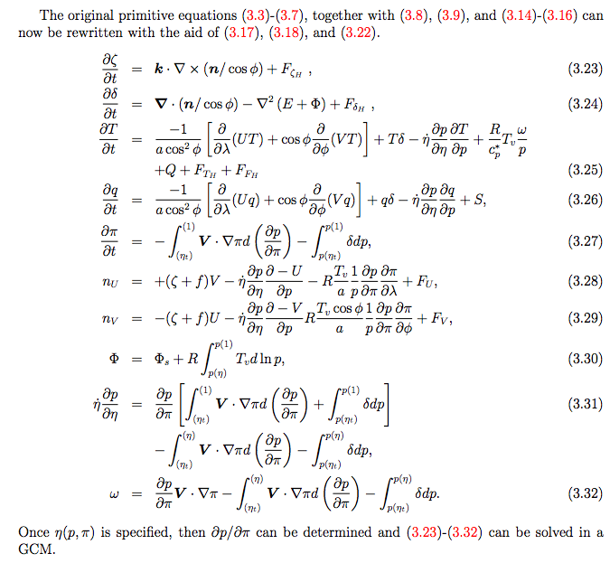](https://scienceofdoom.files.wordpress.com/2015/02/screen-shot-2015-02-03-at-7-31-24-pm.png)

As soon as anyone reads this – and if they can’t be bothered to find the reference via Google Scholar and read it, well, what can you say about such people – as soon as they read it, of course, it’s crystal clear that positive feedback isn’t “programmed in” to climate models.

So GCMs all come to the conclusion that more GHGs results in a hotter world (2-6ºC). They solve basic physics equations in a “grid” fashion, stepping forward in time, and so the result is clear and indisputable.

Step 3 – Attribution Studies

I recently spent some time reading AR4 and AR5 (the IPCC reports) on Attribution ([Natural Variability and Chaos – Seven – Attribution & Fingerprints Or Shadows?](http://scienceofdoom.com/2014/12/30/natural-variability-and-chaos-seven-attribution-fingerprints-or-shadows/) and [Natural Variability and Chaos – Three – Attribution & Fingerprints](http://scienceofdoom.com/2014/11/01/natural-variability-and-chaos-three-attribution-fingerprints/)).

This is the work of attributing the last century’s rise in temperature to the increases in anthropogenic GHGs. I followed the trail of papers back and found one of the source papers by Hasselmann from 1993. In it we can clearly see the basis for attribution studies:

[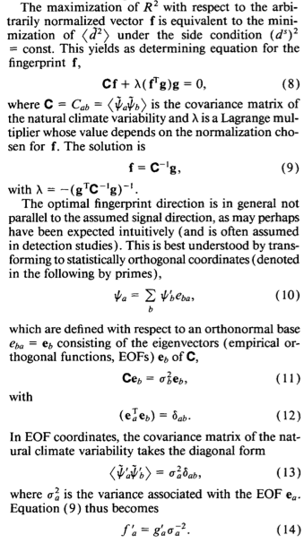](https://scienceofdoom.files.wordpress.com/2015/02/screen-shot-2015-02-03-at-7-40-31-pm.png)

Now it’s very difficult to believe that anyone questioning attribution studies isn’t of evil intent. After all, there is the basic principle in black and white. Who could be confused?

As a side note, to excuse my own [irredeemable article](http://scienceofdoom.com/2014/12/30/natural-variability-and-chaos-seven-attribution-fingerprints-or-shadows/) on the topic, the actual basis of attribution isn’t just in these equations, it is also in the assumption that climate models accurately calculate the statistics of natural variability. The IPCC chapter on attribution doesn’t really make this clear, yet in another chapter (11) different authors suggest completely restating the statistical certainty claimed in the attribution chapter because “..it is explicitly recognized that there are sources of uncertainty not simulated by the models”. Their ad hoc restatement, while more accurate than the executive summary, still needs to be justified.

However, none of this can offer me redemption.

Step 4 – Unprecedented Temperature Rises

(This could probably be switched around with step 3. The order here is not important).

Once people have seen the unprecedented rise in temperature this century, how could they not align themselves with the forces of good?

Anthropogenic warming ‘writ large’ (AR5, chapter 2):

[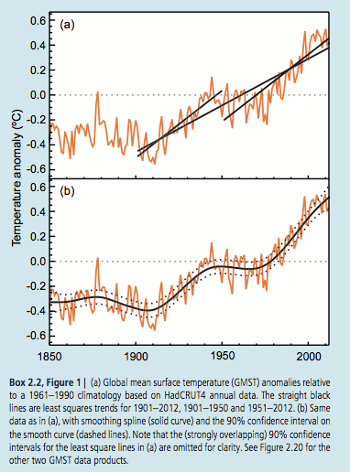](https://scienceofdoom.files.wordpress.com/2015/02/screen-shot-2015-02-03-at-7-54-49-pm.png)

There’s the problem. The last 400,000 years were quite static by comparison:

[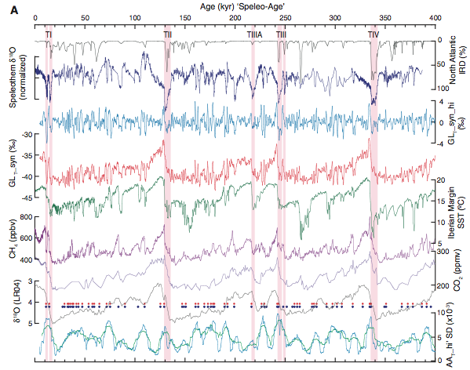](https://scienceofdoom.files.wordpress.com/2015/02/screen-shot-2015-02-03-at-8-03-13-pm.png)

*From ‘800,000 Years of Abrupt Climate Variability’, Barker et al (2011)*

The red is a Greenland ice core proxy for temperature, the green is a mid-latitude SST estimate – and it’s important to understand that calculating global annual temperatures is quite difficult and not done here.

So no one who looks at climate history can possibly be excused for not agreeing with consensus climate science, whatever that is when we come to “consensus paleoclimate”.. It was helpful to read Chapter 5 of AR5:

There is high confidence that orbital forcing is the primary external driver of glacial cycles (Kawamura et al,. 2007; Cheng et al., 2009; Lisiecki, 2010; Huybers, 2011).

I’ve only read about 350 papers on paleoclimate and I’m confused about the origin of the high confidence as I explained in [Ghosts of Climate Past -Eighteen – “Probably Nonlinearity” of Unknown Origin](http://scienceofdoom.com/2014/03/03/ghosts-of-climates-past-eighteen-probably-nonlinearity-of-unknown-origin/).

Anyway, the key takeaway message is that the recent temperature history is another demonstration that anyone not in line with consensus climate science is clearly acting from evil motives.

Conclusion

I thought about putting a photo of the Holocaust from a concentration camp next to a few pages of mathematical equations – to make a point. But that would be truly awful.

That would trivialize the memory of the terrible suffering of millions of people under one of the most evil regimes the world has seen.

And that, in fact, is my point.

I can’t find words to describe how I feel about the apologists for the Nazi regime, and those who deny that the holocaust took place. The evidence for the genocide is overwhelming and everyone can understand it.

On the other hand, those who ascribe the word ‘denier’ to people not in agreement with consensus climate science are trivializing the suffering and deaths of millions of people. Everyone knows what this word means. It means people who are apologists for those evil jackbooted thugs who carried the swastika and cheered as they sent six million people to their execution.

By comparison, understanding climate means understanding maths, physics and statistics. This is hard, very hard. It’s time consuming, requires some training (although people can be self-taught), actually requires academic access to be able to follow the thread of an argument through papers over a few decades – and lots and lots of dedication.

The worst you could say is people who don’t accept ‘consensus climate science’ are likely finding basic – or advanced – thermodynamics, fluid mechanics, heat transfer and statistics a little difficult and might have misunderstood, or missed, a step somewhere.

The best you could say is with such a complex subject straddling so many different disciplines, they might be entitled to have a point.

[The author feels that you have no soul and no empathy for a kind of suffering unless you tweak your notion of what “to deny” means.]

If you have no soul and no empathy for the suffering of millions under the Third Reich, keep calling people who don’t accept consensus climate science ‘deniers’.

Otherwise, just stop.

Important Note: The moderation filter on comments is setup to catch the ‘D..r’ word specifically because such name calling is not accepted on this blog. This article is an exception to the norm, but I can’t change the filter for one article.